Items highlighted in yellow are tasks for you to complete


Items in Blue italics are help tips

These pages are designed to show you how to use software packages; various software updates may have taken place so some pages will not apply to versions other than those listed here. In some cases data files may be required.

MPP100 Starting Power Point worksheet

WORKSHEET
You can use this document (word) or open the

Opening a PowerPoint Presentation File some versions will differ from screens shown here.

- Open Microsoft PowerPoint

- Open a Blank Power Point Presentation and click OPEN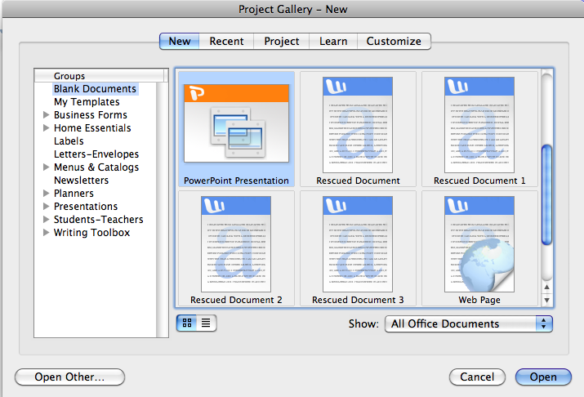
- Select Auto Lay Out or Title Slide

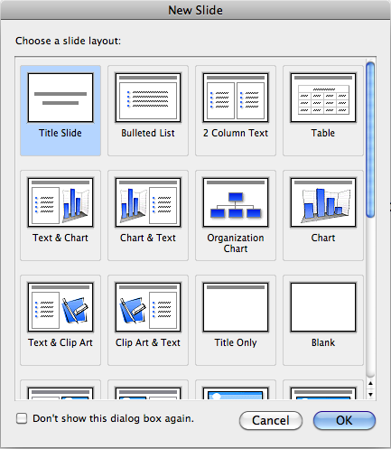

- Select Title Slide (other slides include Blank slide, Title only, Bullet List) and click OPEN

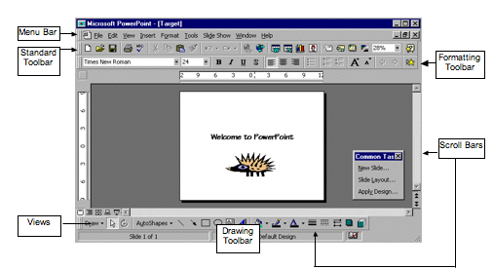

Opening a PowerPoint Presentation File

The Menu Bar:

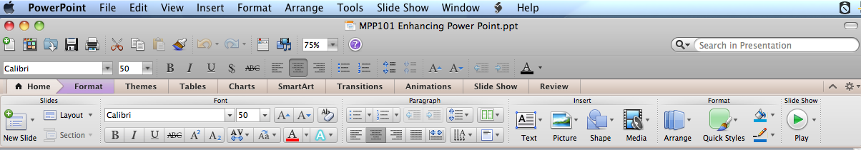

The menu bar contains a set of menus which group similar functions.

The Standard Toolbar:

The Standard toolbar contains buttons that are shortcuts to the common functions we use also found in the Menu Bar. Eg instead of File ➢ Open in the Menu Bar.

The Formatting Toolbar:

The Formatting Toolbar contains drop down lists and buttons which are shortcuts for the common formatting functions we apply to text. These functions are also found in the Menu Bar.

If any toolbars are missing click on View ➢ Toolbars ➢ then the name of the toolbar eg Formatting
- Open the MPP100 Starting Power Point worksheet.ppt

It is more practical to open the power point worksheet, where you can undertake the work side by side with two power points on the left view at 75%

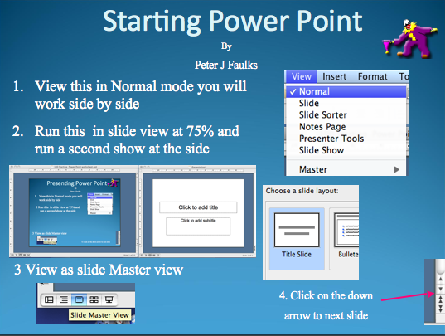

- Click to ADD Title or Click to add subtitle heading
- Add to title “My Presentation”
- Add to subtitle your “Name:”

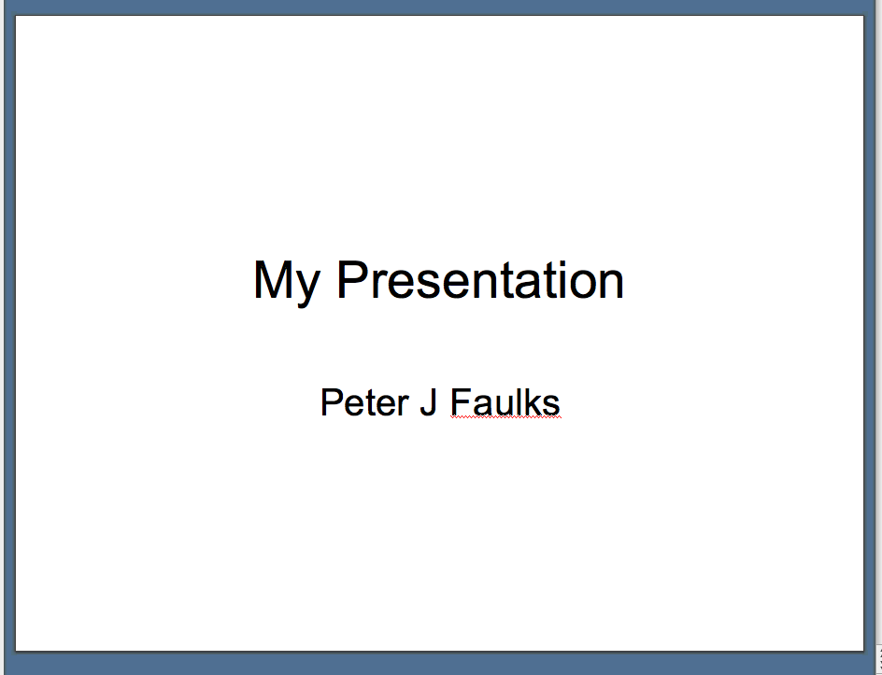

Saving the PowerPoint Presentation File
- Go to the File Menu
- Select Save As
- Select your drive
- Save into your class folder or the Term specified.
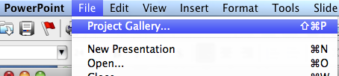
Using File - Project Gallery Design Templates, scroll

Down to select the Chute design (or any that you like).

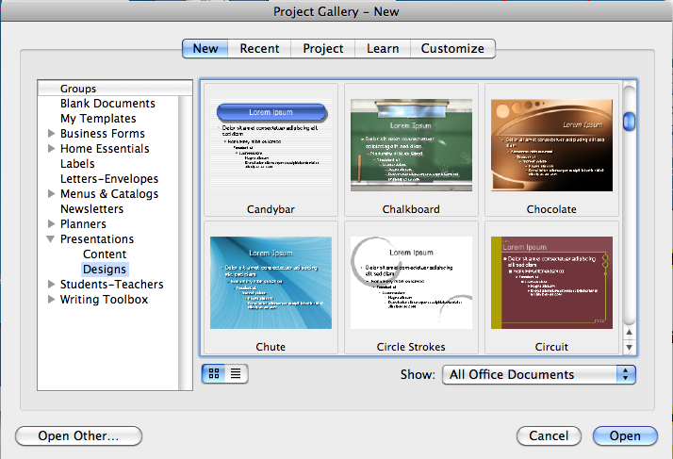

Editing Text
(Showing how to change the size, colour and font of text)
- Show how the title can be aligned
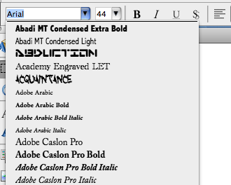

- Increase Title font size from 44pts to 60pts
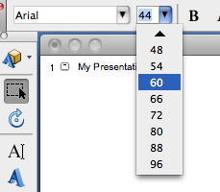

- Decrease sub-title font size from 32pts to 20pts
- Use Bold, Italics, Underline
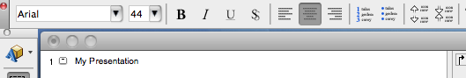
- or Shadows to also edit text
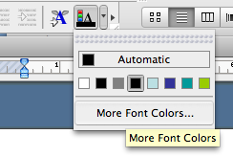
- To change text colour, highlight text and select font colour (A – this can also be found in the drawing tool, under View menu – Toolbars - Drawing)

Moving the title and sub-title section
- Click and drag selected text

Move the titles to the top of the presentation slide
This is how it might look
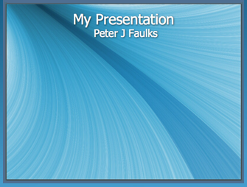

- Change My Presentation to About Dinosaurs

- Move this to the top of the slide



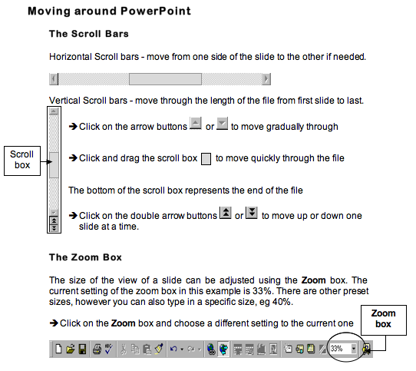

Open the slide sorter, select Slide Sorter View

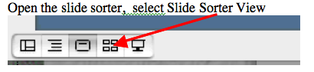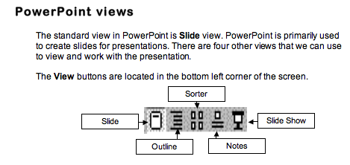

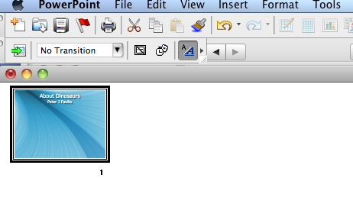

To Move Slides

Suppose you want to move Slide 6 to become Slide 3, you simply select Slide 6 and drag it to the Slide 3 position.

- Click on Slide 6 to select it

- Hold the mouse button down and drag the mouse to where you want the slide to appear, a greyed line will move with the mouse and appear between slides as you move

- Release the mouse when the greyed line has appeared just after Slide 2

On release of the mouse, your slides will be resorted and renumbered.

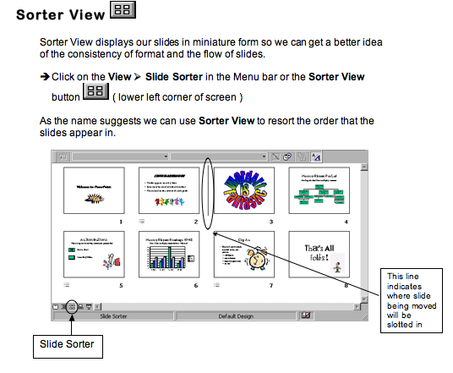Duplicating a Slide
- Select on the slide which you wish to duplicate
- Select Copy then hit paste 10 times (CTRL +C or CMD+C)
- Duplicate your slide to create 10 slides (Note you can use the slide sorter to copy and paste your slide)
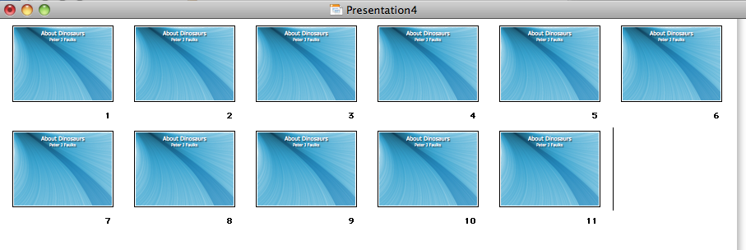
Deleting a Slide
- Select on the slide which you wish to delete
- Go to the Edit menu and select Delete Slide

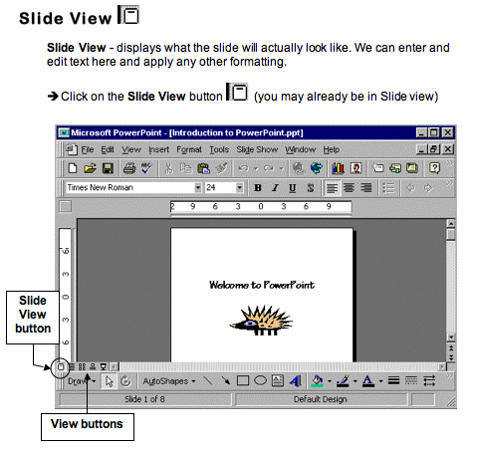Inserting Images
- Go to the Insert Menu
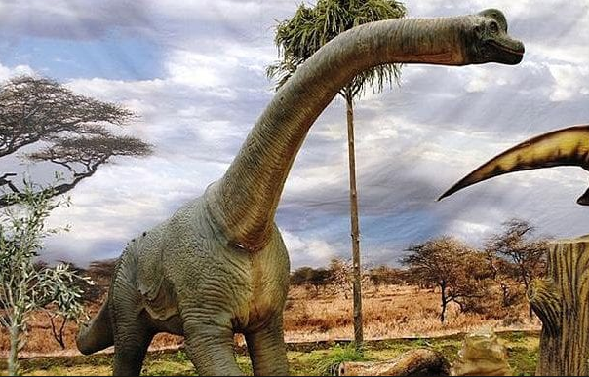
- Select a picture (of a Dinosaur from the MPP100 Power Point Folder or .zip file dinosaurs.zip) or Download some images of Dinosaurs from the Internet

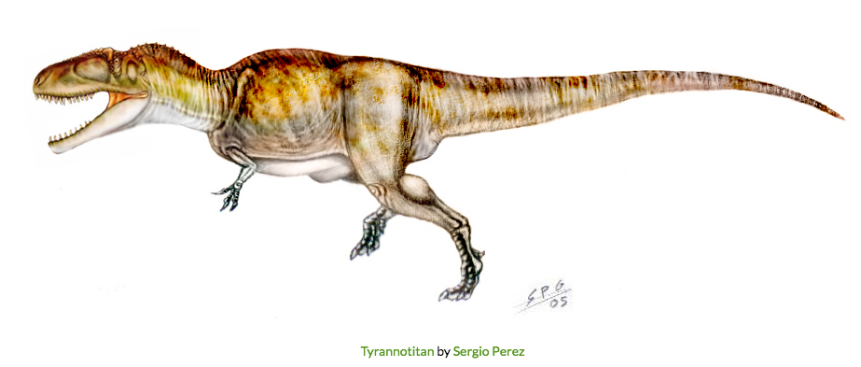

- Select From a File
- Click on image
- Insert a picture
- Move and Drag the inserted image around the slide with your mouse.
- Reduce the image to fit the slide

Inserting Images from Clip Art
- Go to the Insert Menu
- Select from Clip Art
- Click on Clip Art
- Select an image
- Insert
- Close Clip Art
- Move and Drag the inserted image around the slide with your mouse.
- Reduce the image to fit the slide

Inserting Images from WordArt
- Go to the Insert Menu
- Select Picture – Word Art
- Use word art and type About Dinosaurs place this in the bottom left hand corner

Inserting Images to each slide
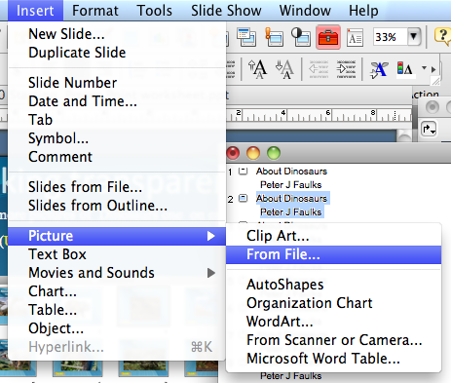

Center on page and reduce size to suit

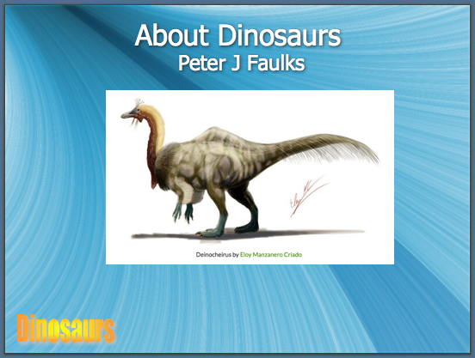
Open the word documents about Dinosaurs and use the text to create information about each Dinosaur don't forget to add the refrerence to any sources or pictures used

Adding bullet points in the subtitle section of the slide
Insert a text box to one side
Add bullet points

- May have climbed trees like modern sloth's
- Deinocheirus is the largest bird mimic of all time
- Weighs as much as an African Elephant
- Was 3 car lengths long
- Was as large as a Tyrannosaurus Rex
- Had 10 inch claws and 8 foot long arms

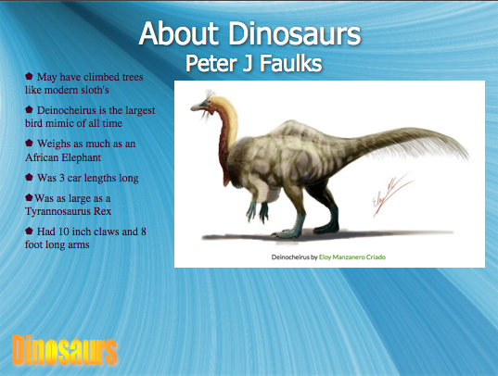

Save your work

Complete the slide show and we will add some animation and slide transitions

Additional exersizes to try


Need help just ask

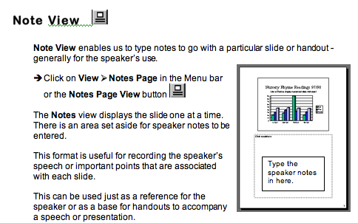

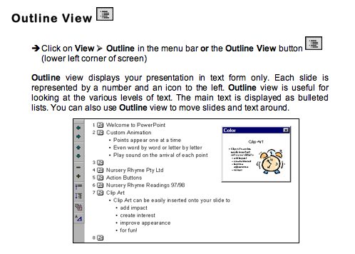Filling in the Background with Colours
- Go to the Format Menu
- Select Background
- Drag the drop down menu
- Select More Colours or
- Select Fill Effects:
  - Gradients Colours= Two Colours
  - Shading Styles= Diagonal Down
  - Shading Styles = From Corner

Inserting a Background Image
- Go to the Insert Menu
- Select Picture, Click on Clip Art
- Select Background, Click on background
- Enlarge the background image by extending the image to fit the slide show
- Right mouse click, select Order and click on the Send to Back selection

Viewing the PowerPoint Presentation
- Task bar is located on bottom right hand corner of the window i.e.,
- Explore the five icons on this task bar: Normal View, Outline View, Slide View, Slide Sorter View and Slide Show

Creating Slide Show Effects
- Select or highlight an area of text or image
- Go to Slide Show Menu
- Select Preset Animation
- Click on Fly From Top
- Repeat step one to create different effects for different areas in the slide show

Slide Transition
- Go to Slide Show menu
- Select Slide Transition, a window will appear on the right hand side of the screen.
- Examine the following:
  - Apply to selected slide
  - Modify transition
  - Advance Slide

Ending a Slide Show
- Right click on the mouse
- Select End Show to exit the Slide Show

